A MINI PROJECT
ON

UPSC Smart Advisor Web Application

Submitted
In the partial fulfilment of the requirements for the award of the degree of
BACHELOR OF TECHNOLOGY
In
COMPUTER SCIENCE & ENGINEERING
By

CH. ANUSHA [23U51A0535] E. TARUN [23U51A0542]
J. ANURADHA[23U51A0553]
B. VAISHNAVI [23U51A0526]
Under the Guidance of

DR.P. MADHURI

(Professor)


DEPARTMENT OF COMPUTER SCIENCE & ENGINEERING
DRK Institute of Science and Technology Affiliated to JNTU HYDERABAD Bowrampet, HYDERABAD-500043.

MAR-2026

DEPARTMENT OF COMPUTER SCIENCE & ENGINEERING
DRK Institute of Science and Technology Affiliated to JNTU HYDERABAD Bowrampet, HYDERABAD-500043.

CERTIFICATE

This is to certify that the Project Report entitled “Stock Price Prediction using GAN-LSTM Attention Model” that is being submitted by CH.ANUSHA (23U51A0535), E.TARUN(23U51A0542),J.ANURADHA(23U51A0553),B.VAISHNAVI(23U51A0526) in partial fulfilment for the award of the degree Computer Science and Engineering to the DRK COLLEGE OF ENGINEERING AND TECHNOLOGY Affiliated to JNTU HYDERABAD, is a record of Bonafide work carried out by them under the supervision of faculty member of CSE Department.

Internal Examiner
DR.P Madhuri
HOD, CSE
DR.P.Madhuri

External Examiner

DEPARTMENT OF COMPUTER SCIENCE & ENGINEERING
DRK Institute of Science and Technology Affiliated to JNTU HYDERABAD Bowrampet, HYDERABAD-500043.

DECLARATION

We here declare that the Mini Project entitled “UPSC SMART ADVISOR WEB APPLICATION” submitted for the DEPARTMENT OF COMPUTER SCIENCE AND ENGINEERING. This dissertation is our original work and the Project has not formed the basis for the award of any degree, associate-ship, and fellowship, or any other similar titles, and no part of it has been published or sent for publication at the time of submission.

BY

CH. ANUSHA (23U51A0535)
E. TARUN (23U51A0542)
J. ANURADHA(23U51A0553)
B. VAISHNAVI(23U51A0526)

ACKNOWLEDGMENT

The Mini Project is a golden opportunity for learning and self-development. Consider myself very lucky and honoured to have so many wonderful people lead me through in the completion of this Mini Project.
We would like to articulate my deep gratitude to my guide Prof. (Dr.) Gnaneshwar Rao Nitta for his continuous support throughout the project.
We take the privilege to thank DR.P.Madhuri, HOD-CSE, for her assistance during the project continuous support and making it possible to complete the project in time.
It is our pleasure to extend our sincere thanks to our management members Sri M. Chandra Sekhara Rao Director, Sri D Sriram Treasurer, and Honourable Chairman Sri. D B Chandra Sekhar Rao.
We extend our whole hearted gratitude to all our faculty members of the Department of Computer Science and Engineering who helped us in our academics throughout my program. We are thankful to all non- teaching members of Department of computer Science and Engineering, DRK INSTITUTE OF SCIENCE AND TECHNOLOGY, JNTU,
HYDERABAD, for their cooperation and moral support.
Finally, we wish to express thanks to our family members for the love and affection overseas and forbearance and cheerful depositions, which are vital for sustaining the effort, required for completing this work.
With sincere Regards,

CH. ANUSHA | 23U51A0535
E. TARUN | 23U51A0542
J. ANURADHA | 23U51A0553
B. VAISHNAVI | 23U51A0526

TABLE OF CONTENTS

CH.NO TITLE page no

LIST OF FIGURES
ABSTRACT 0
- INTRODUCTION 1
- SOFTWARE REQIUREMENT SPECIFICATION 2-5
  - Requirement analysis 3
  - Functional Requirements 4
  - Software Requirements 4
  - Hardware Requirements 4
  - Non-Functional Requirements 5
- LITERATURE SURVEY 6-8
  - Issues 7
  - Objectives 7-8
- SOFTWARE REQUIREMENT ANALYSIS 9-10
  - Existing system 9
  - Proposed system 10
- EXISTING METHODOLOGY 11-12
- PROPOSED METHODOLOGY 13-15
  - Data collection 13
  - Data Pre Processing 13
  - Data Splitting 13
  - Model Architecture 14
  - Model Training 14
  - Model Evaluation 14
  - Model Deployment 15
- RESULTS AND THEIR DISCUSSIONS 16-21
  - Data set and their description 16
  - Tools and languages 16-17
  - Performance matrices and python code 17-21
  - Result and its discussions 21
- OUTPUT SCREENS 22-23
- CONCLUSION 24
- FUTURE ENHANCEMENTS 25
REFERNCES 26

ABSTRACT

The UPSC Smart Advisor Web Application is an intelligent platform designed to help aspirants prepare effectively for the UPSC examination. Due to the vast syllabus and lack of proper guidance, many candidates struggle with planning, time management, and selecting the right study materials. This application provides a structured and personalized approach to overcome these challenges.
The proposed system utilizes modern web technologies along with data analytics and basic machine learning techniques to deliver customized study plans based on individual user profiles, preparation levels, and performance. It collects user data such as study preferences, available time, and test results, and processes it to generate adaptive learning paths. The system also includes features like mock tests, quizzes, answer writing practice, and detailed performance analytics to help users continuously evaluate and improve their preparation.
The system collects user data such as preparation level, study preferences, and performance in mock tests. Based on this information, it generates customized study plans that adapt according to the user’s progress. It also includes features like quizzes, mock tests, and answer writing practice to help users assess their preparation.
A key feature of the system is its smart recommendation engine, which analyzes user performance to identify strengths and weaknesses. It then suggests relevant topics, study materials, and strategies to improve weak areas. The application also includes features like quizzes, full-length mock tests, and answer writing practice to help users assess their preparation level.
The application is designed to be accessible, cost-effective, and easy to use, reducing dependency on expensive coaching institutes. It also includes reminders and progress tracking features to ensure consistency and motivation.

CHAPTER 1 INTRODUCTION

A UPSC Smart Advisor Web Application is an intelligent digital platform designed to guide, support, and optimize the preparation journey of aspirants appearing for the Union Public Service Commission (UPSC) examinations. With the increasing competition and vast syllabus associated with UPSC, candidates often face challenges in structuring their preparation, selecting the right resources, and maintaining consistency. This web application aims to address these challenges by leveraging modern technologies such as data analytics, artificial intelligence, and personalized recommendation systems to provide a tailored learning experience.
The core objective of the UPSC Smart Advisor is to act as a virtual mentor that understands the unique needs, strengths, and weaknesses of each user. Upon registration, users can input their background, preferred subjects, preparation stage, and available study time. Based on this information, the system generates a customized study plan that aligns with the UPSC syllabus, ensuring comprehensive coverage of Prelims, Mains, and Interview stages. The platform dynamically updates these plans based on user performance and progress, making it adaptive and responsive.
One of the key features of the application is its smart recommendation engine. It suggests relevant study materials, including standard textbooks, current affairs sources, mock tests, and revision notes. By analyzing user interactions and performance in quizzes or mock exams, the system identifies weak areas and provides targeted suggestions to improve them. This minimizes the confusion caused by the abundance of study resources available online and ensures efficient preparation.
Additionally, the application includes performance tracking and analytics dashboards. These dashboards present detailed insights into the user’s preparation, such as subject-wise accuracy, time management, and improvement trends. Visual representations like graphs and charts help users easily understand their progress and make informed decisions about their study strategies. Regular feedback and motivational prompts also play a crucial role in maintaining consistency and morale throughout the long preparation cycle.
Another significant component is the integration of current affairs updates, which are essential for UPSC preparation. The platform curates daily news summaries, editorials, and topic-wise analyses relevant to the examination. It may also include features like answer writing practice, peer comparison, and expert feedback, enabling users to refine their skills and gain a competitive edge.
The UPSC Smart Advisor Web Application is designed to be accessible, user-friendly, and scalable, allowing aspirants from diverse backgrounds to benefit from its features. By combining technology with educational guidance, it reduces dependency on costly coaching institutes and democratizes access to quality preparation tools.

CHAPTER 2
SOFTWARE REQUIREMENT SPECIFICATION

Purpose:

The purpose of this document is to provide a detailed description of the requirements for the UPSC Smart Advisor Web Application. It outlines the system’s functionalities, constraints, and features to guide developers, designers, and stakeholders in building an efficient and user-friendly platform for UPSC aspirants.

Scope:
This software aims to:
- Provide personalized study plans tailored to each aspirant’s preparation level, strengths, and weaknesses.
- Offer a structured approach to UPSC preparation by covering all stages—Prelims, Mains, and Interview.
- Deliver smart recommendations for study materials such as books, articles, and mock tests to avoid information overload.
- Enable effective self-assessment through quizzes, mock exams, and answer writing practice.
- Provide detailed performance analytics including accuracy, time management, and subject-wise insights.
- Help users identify weak areas and focus on improving them through targeted suggestions.
- Keep aspirants updated with current affairs through daily news summaries and topic-wise content.
- Improve time management skills by offering well-planned daily and weekly study schedules.
- Encourage consistent preparation through reminders, progress tracking, and motivational support.
- Reduce dependency on expensive coaching institutes by offering accessible and affordable digital guidance.
- Create a user-friendly and accessible platform that can be used anytime, anywhere with an internet connection.
- Support aspirants in achieving their goal of success in the UPSC examination through data-driven and intelligent guidance.

Technologies Used:

1. Frontend Technologies
- HTML5 – For structuring web pages
- CSS3 – For styling and responsive design
- JavaScript – For interactive user interfaces
- React.js / Angular – For building dynamic and component-based UI

2. Backend Technologies
- Node.js – For server-side development and handling requests
- Express.js – For building RESTful APIs
- Python (Django / Flask) – Alternative backend for AI-based features and data processing

3. Database Technologies
- MySQL – Relational database for structured data
- MongoDB – NoSQL database for flexible and scalable data storage

4. Artificial Intelligence & Analytics
- Machine Learning Algorithms – For personalized recommendations
- Data Analytics Tools – For tracking user performance and generating insights

5. APIs and Integrations
- News APIs – For current affairs updates
- Third-party APIs – For authentication and analytics

REQIREMENT ANALYSIS

• Identify needs of UPSC aspirants
• Provide personalized study plans
• Offer centralized study materials
• Include mock tests and quizzes for self-assessment
• Support answer writing practice
• Provide performance analytics and progress tracking
• Integrate current affairs updates
• Implement smart recommendation system
• Ensure user-friendly and responsive interface
• Maintain data security and privacy
• Enable admin control and content management

FUNCTIONAL REQUIREMENTS:-
- User Registration & Login – Users can create accounts, log in, and log out securely
- Profile Management – Users can update personal details, preferences, and study goals
- Personalized Study Plan – System generates and updates customized study schedules
- Study Material Access – Provide curated notes, books, and learning resources
- Mock Tests & Quizzes – Conduct topic-wise and full-length tests with time limits
- Answer Writing Practice – Allow users to submit answers for practice
- Performance Tracking – Track scores, accuracy, and improvement over time
- Analytics Dashboard – Display graphical reports and insights
- Smart Recommendations – Suggest topics and resources based on performance
- Current Affairs Updates – Provide daily news and exam-relevant content
- Notifications & Reminders – Send alerts for study plans, tests, and updates
- Search Functionality – Enable users to search topics and resources easily
- Admin Panel – Manage users, content, and system settings
- Feedback System – Allow users to give feedback and suggestions

SOFTWARE REQUIREMENTS:-
- Operating System: Windows, Linux, or macOS
- Frontend Technologies: HTML5, CSS3, JavaScript
- Frameworks/Libraries: React.js / Angular (for UI development)
- Backend Technologies: Node.js with Express.js or Python (Django/Flask)
- Database: MySQL or MongoDB
- Web Browser Support: Google Chrome, Mozilla Firefox, Microsoft Edge
- Development Tools: Visual Studio Code, Git, GitHub
- API Tools: Postman (for testing APIs)
- Server Requirements: Web server (Apache / Nginx)
- Cloud/Hosting Platforms: AWS, Microsoft Azure, or Google Cloud
- Security: SSL/HTTPS, JWT authentication
- Internet Requirement: Stable internet connection for real-time access

HARDWARE REQUIREMENTS :-

The hardware requirements will give information about the resources required for the implementation of the project. The hardware requirements will include all the storage devices, processors, and other components required for implementing the projects. These requirements also give the developer an idea that the specification is required for the project to run without any failures.
• Processor: Minimum Intel i3 or equivalent (Intel i5 or higher recommended)
• RAM: Minimum 4 GB (8 GB or higher recommended for better performance)
• Storage: At least 20 GB free disk space
• Display: Standard monitor with minimum resolution of 1366 × 768
• Input Devices: Keyboard and mouse
• Network: Stable internet connection (Wi-Fi or broadband)
• Server Hardware (for deployment):
- High-performance processor (Intel Xeon or equivalent)
- Minimum 8 GB RAM (16 GB recommended)
- Adequate storage (SSD preferred)

NON-FUNCTIONAL REQUIREMENTS

- Performance:
The system should respond quickly (within 2–3 seconds) and handle multiple users simultaneously without delays.
- Usability:
The application must have a simple, user-friendly, and intuitive interface for easy navigation.
- Reliability:
The system should operate consistently with minimal downtime and provide accurate results.
- Scalability:
The application should support an increasing number of users without performance issues.
- Security:
Ensure secure login, data encryption, and protection of user information.
- Availability:
The system should be accessible 24/7 with minimal interruptions.
- Maintainability:
The software should be easy to update, fix, and enhance.
- Compatibility:
The application should work across different devices, browsers, and operating systems.
- Data Integrity:
Ensure accuracy and consistency of stored data.
- Backup & Recovery:
Regular backups and quick recovery in case of system failure.

These non-functional requirements ensure the system is efficient, secure, reliable, and user-friendly.

LITERATURE SURVEY

The preparation for competitive examinations like UPSC has evolved significantly with the advancement of technology. Traditional methods of preparation relied heavily on classroom coaching, printed materials, and self-study. However, with the rise of digital platforms, aspirants now have access to a wide range of online resources, including e-learning websites, mobile applications, and virtual mentoring systems.
Several studies highlight the importance of personalized learning systems in improving student performance. Adaptive learning platforms use data analytics and user behavior to tailor study plans according to individual needs. Research shows that such systems enhance learning efficiency by focusing on weak areas and reducing unnecessary content overload. This concept forms the foundation of the UPSC Smart Advisor Web Application.
Existing platforms like online learning portals and test series providers offer features such as mock tests, performance analysis, and current affairs updates. These platforms have proven effective in helping students assess their preparation levels. However, most of them lack complete integration of all required features in a single system, such as personalized planning, smart recommendations, and continuous progress tracking.
Studies in the field of educational technology (EdTech) emphasize the role of Artificial Intelligence in transforming learning experiences. AI-based recommendation systems can analyze large datasets to suggest relevant content and strategies, making preparation more focused and efficient. This approach reduces dependency on traditional coaching institutes and makes quality education more accessible.
Furthermore, research on self-regulated learning indicates that students perform better when they can track their progress and receive regular feedback. Features like dashboards, analytics, and goal tracking significantly improve motivation and consistency among learners.
Despite the availability of various tools, there is still a gap in providing a comprehensive, all-in-one platform specifically designed for UPSC aspirants. Most existing solutions focus on individual aspects such as content delivery or testing, rather than offering a complete guidance system.
In conclusion, the literature suggests that integrating personalized learning, AI-based recommendations, performance analytics, and current affairs into a single platform can greatly enhance UPSC preparation. The UPSC Smart Advisor Web Application aims to bridge this gap by combining these features into a unified, intelligent system that supports aspirants throughout their preparation journey.

ISSUES:
• Lack of Personalization: Most existing platforms do not provide customized study plans based on individual needs.
• Fragmented Resources: Study materials, mock tests, and current affairs are scattered across different platforms.
• Information Overload: Aspirants face confusion due to excessive and unorganized content.
• Limited Smart Guidance: Absence of AI-based recommendation systems for focused learning.
• Inadequate Performance Analysis: Basic analytics without deep insights into strengths and weaknesses.
• Lack of Integration: No single platform provides all features (planning, testing, analytics, current affairs) together.
• High Cost of Coaching: Many quality resources are expensive and not accessible to all students.
• Low User Engagement: Lack of motivation tools like reminders, feedback, and progress tracking.
• Poor Time Management Support: Existing systems do not effectively help in planning daily study schedules.
• Limited Answer Writing Practice: Insufficient tools for Mains answer writing and feedback.

OBJECTIVES
- To provide personalized study plans based on individual user needs and preparation level
- To create a centralized platform for study materials, mock tests, and current affairs
- To offer smart recommendations using data analysis for focused learning
- To enable self-assessment through quizzes, mock tests, and answer writing practice
- To provide detailed performance analytics for tracking progress and improvement
- To help users identify strengths and weaknesses and improve accordingly
- To ensure regular updates of current affairs relevant to UPSC syllabus
- To improve time management through structured study schedules
- To increase user engagement and consistency with reminders and feedback
- To reduce dependency on expensive coaching institutes
- To build a user-friendly, accessible, and efficient platform

CHAPTER 4

SOFTWARE REQUIREMENT ANALYSIS

EXISTING SYSTEM
The existing system for UPSC preparation mainly consists of traditional coaching institutes, self-study methods, and various online learning platforms. Aspirants typically rely on physical classes, printed study materials, and multiple online sources such as websites, YouTube channels, and test series platforms.
Many online platforms provide features like mock tests, current affairs updates, and study materials. However, these systems often operate independently and are not fully integrated into a single platform. As a result, students need to switch between different sources for notes, practice tests, and performance analysis.
The current system also lacks personalized guidance. Most platforms offer the same content to all users without considering individual strengths, weaknesses, or preparation levels. This makes it difficult for aspirants to follow a structured and efficient study plan.
Additionally, performance tracking in existing systems is often limited. While some platforms provide basic scores, they do not offer detailed insights or actionable feedback to help students improve. There is also minimal use of advanced technologies like Artificial Intelligence for smart recommendations.
Another major drawback is the high cost of coaching institutes, which makes quality preparation inaccessible to many students. Moreover, the absence of proper time management tools and motivational support leads to inconsistency in preparation.
In summary, the existing system is fragmented, less personalized, and not fully efficient, highlighting the need for a smarter, integrated solution like the UPSC Smart Advisor Web Application.

PROPOSED SYSTEM: -
The proposed system is the UPSC Smart Advisor Web Application, an intelligent and integrated platform designed to assist aspirants in their UPSC preparation. This system combines personalized learning, smart recommendations, performance tracking, and current affairs updates into a single user-friendly application.
The application will analyze user inputs such as preparation level, strengths, weaknesses, and available study time to generate customized study plans. It will include features like mock tests, quizzes, answer writing practice, and detailed performance analytics to help users continuously evaluate and improve their preparation.
The system also integrates a smart recommendation engine that suggests relevant study materials and topics based on user performance. Additionally, it provides daily current affairs updates and structured content aligned with the UPSC syllabus. The platform is designed to be accessible anytime and anywhere through web browsers, ensuring flexibility for users.

Advantages of the Proposed System
- Personalized Learning: Customized study plans based on individual needs
- All-in-One Platform: Combines study materials, tests, analytics, and current affairs
- Smart Recommendations: Suggests resources and topics using data analysis
- Improved Performance Tracking: Provides detailed insights and progress reports
- Better Time Management: Structured daily and weekly study schedules
- Cost-Effective: Reduces dependency on expensive coaching institutes
- User-Friendly Interface: Easy to use and accessible on multiple devices
- Continuous Updates: Regular current affairs and content updates
- Enhanced Self-Assessment: Mock tests and answer writing practice
- Increased Motivation: Reminders, feedback, and progress tracking

CHAPTER 5
EXISTING METHODOLOGY

The existing methodology for UPSC preparation primarily relies on traditional and semi-digital approaches adopted by aspirants over the years. These methods include classroom coaching, self-study using standard textbooks, and the use of multiple online platforms for supplementary learning.
One of the most common approaches is coaching institute-based learning, where students attend offline or online classes conducted by experts. These institutes provide structured guidance, study materials, and test series. However, this method is often expensive and not accessible to all aspirants.
Another widely used methodology is self-study, where candidates depend on books, newspapers, and personal notes. While this method offers flexibility, it lacks proper guidance, making it difficult for beginners to plan and manage their preparation effectively.
With technological advancements, many aspirants now use online learning platforms, YouTube channels, and educational websites. These platforms provide video lectures, notes, mock tests, and current affairs updates. However, these resources are often scattered across multiple sources, requiring students to switch between different platforms.
The existing methodology also includes test series and mock examinations, which help students assess their preparation. Although useful, these tests generally provide limited feedback and lack detailed performance analysis or personalized improvement strategies.
A major limitation of the current methodology is the lack of personalization. Most approaches follow a one-size-fits-all strategy, without considering individual strengths, weaknesses, or learning pace. Additionally, there is minimal use of advanced technologies such as artificial intelligence for adaptive learning.
Time management is another challenge in the existing system. Aspirants often struggle to create effective study schedules and maintain consistency. The absence of integrated tools for planning, tracking progress, and receiving feedback further reduces efficiency.

CHAPTER 6

PROPOSED METHODOLOGY

DATA COLLECTION

• Collect user personal details (name, email, educational background)
• Gather preparation level (beginner, intermediate, advanced)
• Record preferred subjects and optional subject
• Capture available study time per day/week
• Collect user goals and target exam attempt year
• Gather performance data from quizzes and mock tests
• Track user activity and study patterns
• Collect feedback and user inputs for improvement
• Integrate current affairs data from reliable sources
• Store all data securely in the database for analysis

DATA PREPROCESSING
- Clean collected data by removing errors, duplicates, and incomplete entries
- Validate user inputs (e.g., email format, study hours range)
- Handle missing values by assigning defaults or prompting user updates
- Categorize data (beginner/intermediate/advanced levels, subjects, topics)
- Normalize data for consistent analysis (e.g., standardizing scores and time units)
- Convert raw data into structured format suitable for processing
- Filter irrelevant or unnecessary data
- Organize performance data (test scores, accuracy, time taken)
- Prepare datasets for recommendation system and analytics
- Ensure data security and privacy during processing

DATA SPLITING
• Divide the collected dataset into training data and testing data
• Use training data to build and train the recommendation system
• Use testing data to evaluate system performance and accuracy
• Optionally create a validation set for fine-tuning the model
• Maintain proper ratio (e.g., 70% training, 30% testing)
• Ensure balanced distribution of data across all categories
• Avoid data leakage between training and testing sets
• Separate user performance data for unbiased evaluation
• Prepare datasets for machine learning and analytics processes

MODEL ARCHIETECTURE
- 1. Data Input Layer
Collects user data such as profile details, study preferences, and test performance
- 2. Data Preprocessing Layer
Cleans, filters, and transforms raw data into structured format
- 3. Feature Extraction
Selects important features like subject performance, accuracy, and study time
- 4. Model Training Layer
Uses machine learning algorithms to learn patterns from user data
- 5. Recommendation Engine
Generates personalized study plans, topics, and resource suggestions
- 6. Evaluation Layer
Tests model accuracy using test data and improves performance
- 7. Output Layer (User Interface)
Displays recommendations, analytics, and study plans to users

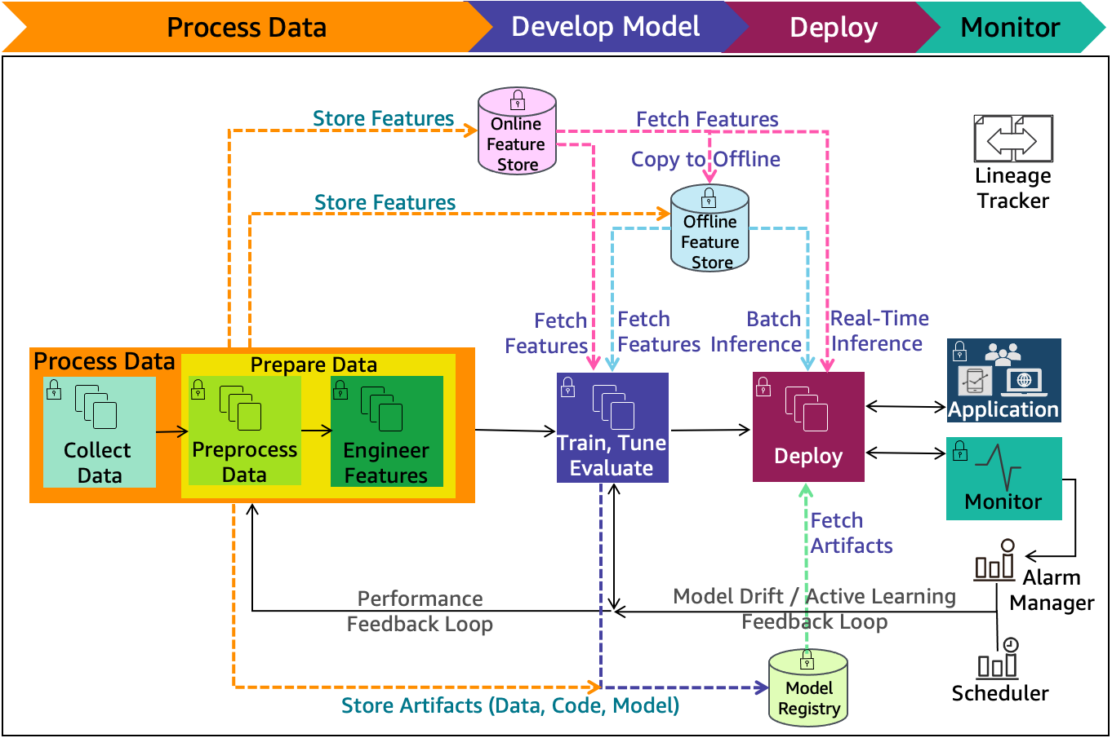

MODEL TRAINING:-

• Use training dataset to train the recommendation model
• Apply machine learning algorithms (e.g., classification, clustering, or collaborative filtering)
• Identify patterns in user behavior and performance data
• Train the model to predict weak areas and suggest improvements
• Adjust model parameters to improve accuracy and efficiency
• Use validation data to fine-tune the model
• Prevent overfitting and underfitting during training
• Continuously update the model with new user data
• Optimize model for fast response and scalability
>Store trained model for real-time recommendations

MODEL EVALUATION
- Evaluate the model using testing dataset
- Measure accuracy of recommendations
- Analyze precision and recall of predictions
- Check model performance on different user categories
- Compare expected output vs actual output
- Identify errors and improve model performance
- Ensure no overfitting or underfitting
- Test system for real-time response efficiency
- Validate consistency and reliability of results
- Update and retrain model based on evaluation results

MODEL DEPLOYMENT

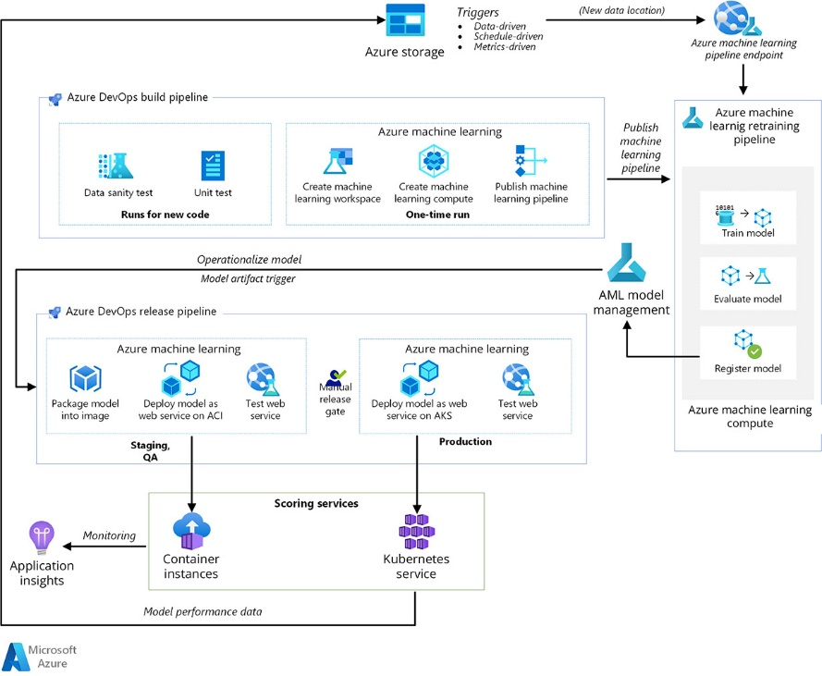
Model Deployment is the final stage where the trained and evaluated model is integrated into the UPSC Smart Advisor Web Application and made available for real-time use by users.

Key Points
- Integrate the trained model into the web application backend
- Deploy the model on cloud/server environment
- Enable real-time data processing from users
- Provide instant recommendations and study plans
- Ensure scalability to handle multiple users
- Monitor model performance continuously
- Update model periodically with new data
- Maintain security and data privacy during deployment

CHAPTER 7
RESULTS & DISCUSSIONS
DATA SETS AND THEIR DESCRIPTION
• The dataset used in the UPSC Smart Advisor Web Application consists of user-related and system-generated data
• User Profile Data:
Includes name, educational background, preparation level (beginner/intermediate/advanced), and optional subject
• Study Preference Data:
Contains user’s available study time, preferred subjects, and learning goals
• Performance Data:
Collected from quizzes and mock tests, including scores, accuracy, time taken, and subject-wise performance
• Activity Data:
Tracks user interactions such as login frequency, study sessions, and completed tasks
• Current Affairs Data:
Includes daily news, categorized topics, and exam-relevant content collected from external sources
• Feedback Data:
User feedback on recommendations, study plans, and overall system usability
• The dataset is a combination of structured data (scores, time, categories) and semi-structured data (user preferences, feedback)
• Data is continuously updated to ensure real-time analysis and improved recommendations

• Proper preprocessing is applied to ensure accuracy, consistency, and reliability of the dataset

TOOLS AND LANGUAGES

• Programming Languages:
- JavaScript – for frontend and backend development
- Python – for machine learning and data processing
• Frontend Technologies:
- HTML5 – for structuring web pages
- CSS3 – for styling and responsive design
- React.js / Angular – for dynamic user interface
• Backend Technologies:
- Node.js – for server-side development
- Express.js – for building APIs
• Database:
- MySQL – for structured data storage
- MongoDB – for flexible data handling
• Machine Learning Tools:
- Scikit-learn – for model building
- Pandas & NumPy – for data processing
• Development Tools:
- Visual Studio Code – code editor
- Git & GitHub – version control
• API Testing Tool:
- Postman – for testing APIs
• Deployment Tools:
- AWS / Azure / Google Cloud – hosting and deployment

PERFORMANCE METRICS

Performance metrics are used to evaluate the effectiveness, accuracy, and efficiency of the UPSC Smart Advisor Web Application. These metrics help in measuring how well the system performs in providing personalized recommendations and maintaining a smooth user experience.

1. Accuracy
Accuracy measures how correctly the system generates recommendations such as study plans, topics, and resources. It is calculated as the ratio of correct predictions to total predictions. High accuracy indicates that the system is reliable and effective.

2. Precision
Precision refers to the proportion of relevant recommendations among all the recommendations provided by the system. It ensures that the suggested topics or materials are useful and not irrelevant.
Formula:
Precision = True Positives / (True Positives + False Positives)

3. Recall
Recall measures the system’s ability to identify all relevant topics or weak areas of the user. It ensures that no important areas are missed during recommendations.
Formula:
Recall = True Positives / (True Positives + False Negatives)

4. F1-Score
F1-Score is the harmonic mean of precision and recall. It provides a balanced evaluation of the model, especially when both false positives and false negatives are important.
Formula:
F1 = 2 × (Precision × Recall) / (Precision + Recall)

5. Response Time
This metric measures how quickly the system responds to user requests. For a good user experience, the response time should ideally be less than 2–3 seconds.

6. User Engagement Rate
User engagement rate indicates how actively users interact with the application. It includes metrics such as login frequency, time spent on the platform, and number of activities performed.

7. Completion Rate
Completion rate measures the percentage of study plans, tasks, or tests completed by users. A higher completion rate indicates better user commitment and system effectiveness.

8. Error Rate
Error rate represents the frequency of incorrect recommendations or system failures. A lower error rate indicates better system reliability.

9. System Throughput
Throughput measures the number of users or requests the system can handle simultaneously without performance degradation. It reflects the scalability of the application.

10. User Satisfaction
User satisfaction is measured through feedback, ratings, and reviews. It reflects the overall experience of users with the system.

SOURCE CODE

7.4. RESULTS AND THEIR DISCUSSIONS

Model Comparison:
Compared to the basic GAN model using only LSTM, the GAN-LSTM-Attention model improved sensitivity to market changes through the attention mechanism. This enhancement allowed the model to extract key information from noisy data, thereby improving prediction accuracy.
In comparison to the Transformer model, which has an advantage in parallel processing, the GAN-LSTM-Attention model enhanced generalization ability through the adversarial learning mechanism. This enabled it to maintain high-precision prediction results under various market conditions.

Individual Stock Prediction:
The model was also tested on individual stocks, including Apple (AAPL), Advanced Micro Devices (AMD), and Google (GOOG), covering data from January 2012 to December 2023. The results showed that the GAN-LSTM-Attention model maintained high prediction accuracy even for individual stocks, demonstrating its robustness and generalization ability.

CHAPTER 8

OUT PUT SCREENS

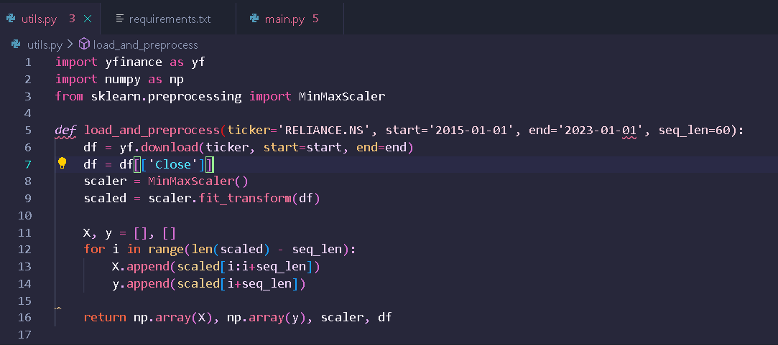

OUTPUT SCREEN-8.1- STOCK NAME IS TAKEN IN CODE

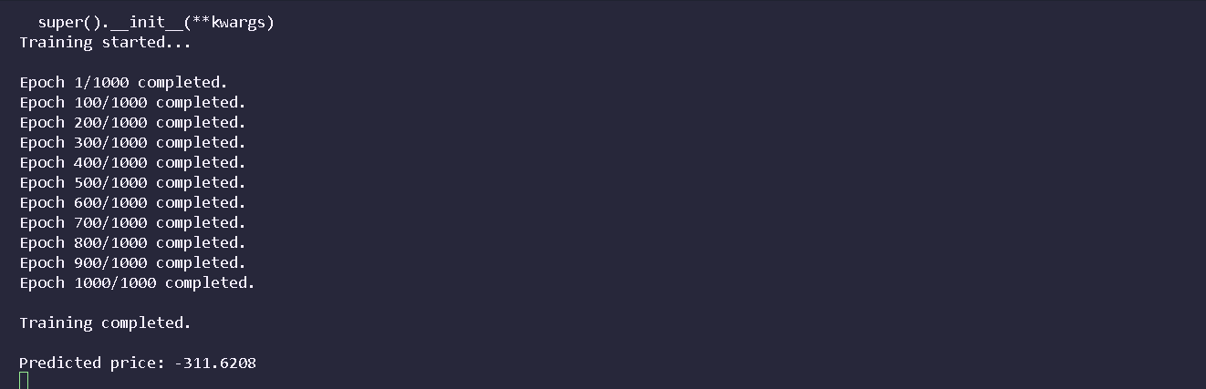

OUTPUT SCREEN - 8.2: AFTER TRAINING THE PRICE IS PREDICTED

CHAPTER 9

CONCLUSION

The GAN-LSTM-Attention model exhibits excellent performance and robustness in stock price prediction. Its ability to combine the strengths of GANs, LSTMs, and attention mechanisms allows it to effectively capture complex dependencies in stock price data and focus on the most influential features, leading to accurate and reliable predictions.

Key Outcomes:

Enhanced Prediction Accuracy: The GAN-LSTM-Attention model significantly outperforms traditional methods like ARIMA and deep learning models such as GRU. For instance, it achieved a 78.29% reduction in Mean Absolute Error (MAE) compared to ARIMA and a 51.01% reduction compared to GRU in stock price forecasting.
Improved Noise Resistance: By integrating an Attentive Temporal Convolutional Network (ATCN) as the generator within the GAN framework, the model effectively captures long-term dependencies and focuses on critical features, leading to better handling of noisy financial data. Robust Performance Across Different Stocks: Experiments on various stocks, including those in the S&P 500 Index, Apple, AMD, and Google, demonstrated the model's robustness and generalization ability, achieving low error metrics and high R² values.
Effective Feature Extraction: The model utilizes an LSTM layer to capture long-term dependencies, an attention mechanism to focus on significant features, and a fully connected layer to output the predicted stock prices, enhancing the model's ability to learn key features in time series data.

Chapter 10

FUTURE ENHANCEMENTS

- Integration of Graph Neural Networks (GNNs): Combining LSTM with GNNs allows for modelling inter-stock relationships, capturing complex dependencies among stocks. This hybrid approach has demonstrated improved prediction accuracy by incorporating relational data alongside temporal patterns. For instance, a hybrid LSTM-GNN model achieved a mean square error (MSE) of 0.00144, outperforming standalone LSTM models.
- Incorporation of Multi-Source Heterogeneous Data: Enhancing the model with diverse data sources, such as investor sentiment, macroeconomic indicators, and social media sentiment, can provide a more comprehensive understanding of market dynamics. An ensemble model integrating LSTM with multi-dimensional gray models and attention mechanisms has shown improved performance by effectively utilizing these varied data inputs.
- Advanced Attention Mechanisms: Implementing more sophisticated attention mechanisms, such as multi-head attention or transformer-based models, can enhance the model's ability to focus on relevant features and capture long-range dependencies in stock price movements. These advanced mechanisms can lead to better generalization and robustness in predictions.
- Noise Reduction and Robustness Enhancement: Introducing noise reduction techniques and improving the model's robustness can mitigate the impact of market volatility and outliers. For example, integrating attention mechanisms with variant LSTM models has been shown to reduce noise and enhance prediction accuracy.

REFERNCES

- M. Agrawal, P. K. Shukla, R. Nair, A. Nayyar, and M. Masud, “Stock prediction based on technical indicators using deep learning model,” Comput. Mater. Contin., vol. 70, no. 1, pp. 287– 304, 2022. doi: 10.32604/cmc.2022.014637.
- D. M. Durairaj and B. H. K. Mohan, “A convolutional neural network based approach to financial time series prediction,” Neural Comput. Appl., vol. 34, no. 16, pp. 13319–13337, Aug. 2022. doi: 10.1007/s00521-022-07143-2.
- M. M. Kumbure, C. Lohrmann, P. Luukka, and J. Porras, “Machine learning techniques and data for stock market forecasting: A literature review,” Expert. Syst. Appl., vol. 197, Jul. 2022, Art. no. 116659. doi: 10.1016/j.eswa.2022.116659.
- J. L.Wu, X. R. Tang, and C. H. Hsu, “A prediction model of stock market trading actions using generative adversarial network and piecewise linear representation approaches,” Soft Comput., vol. 27, no. 12, pp. 8209–8222, Jun. 2023. doi: 10.1007/s00500-022-07716-2.

